Have We Forgotten the Poor?
October 12, 2019

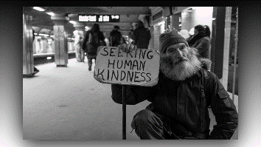
Jesus began, “Children, when you take care of the poor, you have come the closest you will ever come to touching My Body on the Cross. This is an understanding that is lost to many mainstream Christians. It simply is not understood that My suffering Body presents itself every day to you in the form of the poor and suffering.

“That smile you give an immigrant is actually a smile that I feel and enjoy. While others are scoffing and being ugly to them, your smile comforts My heart. They are made in My image, just as you are. I inhabit the poor in ways you will never understand until Heaven.

“The poor are My gift to you. Otherwise, you would never have the opportunity to do good to Me if you did not have them with you. It tears at My Heart to see them abused and pushed away. Yes, it is true that many poor have resorted to stealing to stay alive. Can I fault them for that, when My lukewarm Body is not caring for their needs? Wouldn’t you do the same if your wife and children were starving?

“All of you are only one second away from extreme poverty. In any moment, a world-wide catastrophe could occur that would wipe away all you owned—and then you would be on the streets with them. You would see what it feels like to be looked down on, and unappreciated. Then you would feel the sting of rejection and hatred that I must endure day after day as the homeless are abused and ignored.

“Yes, you worked for all you own—but who gave you the ability to work? Who gave you good parents, a sound mind, an education, a healthy body? Do you not realize that these were gifts to you with your birthright, which I chose for you? In a millisecond, all of this could be taken away. One serious injury and you would be helpless and dependent on a system… or on My Body, that is not always attention to their neighbors' needs.

“I love you all dearly, but I want you to know that neglect, scorn, and contempt daily are My lot as I sit beside them on the street and speak hope to their hearts. Those care—less glances wound Me deeply, because you just did it to Me. I presented you with an opportunity to bless My Heart and you walked right by it.

“These are not teachings you will hear commonly from the pulpit. But those of you who are here, and are looking for more Truth, deeper Truth, dwelling closer to Me—even in My Heart. And I tell you the Truth: whatever you have done to the least of these, truly, you have done it unto Me.

“Go now, My dearly beloved ones, and reflect the Love I have shed in your hearts to the poor and the dying and the confused. You will once again light up My world and My Heart with your love.”

